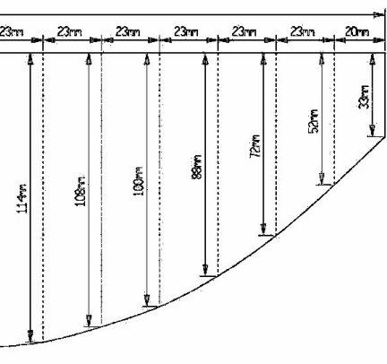
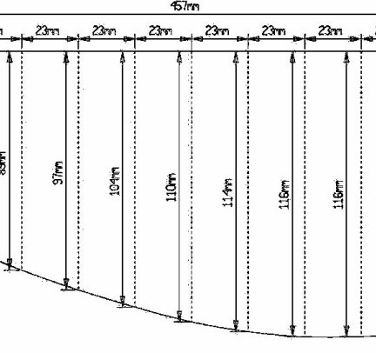
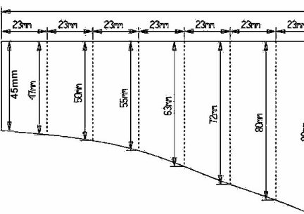
Restricted class:
18" x 8" inch hull size and floor shape as per plan.
Single Motor up to 540 size ( gearing etc. allowed )
Up to 7.2 volts
SINGLE RUDDER BLADE TYPE up 4" Sq.
Must have a superstructure of some sort.
Unlimited Class:
As above except;
Any rudder arrangement up 4" Sq.
SINGLE MOTOR but any propeller arrangement you can invent.

Construction Notes:
Size 18" (460mm) long, 8" (200mm) wide
Hull profile as per plans.
Construction material, anything, any weight.
No sharp corners on hull edge to stop damage to other boats in combat
Superstructure
There must be a superstructure above the decks Min size 4"x4"x4" (100mm x 100mm x 100mm) whole or in parts, other than that whatever you like, tugs, warships, tanks, house, duck, sailing ship, shed, car, etc, etc.
Drive
Motor will be 540 (Speed 600) or less.
Any gears reductions clutches etc allowable but must not be used to steer the boat in any way.
Single propshaft with Single propeller 11\2 inch (40mm) Dia.
Power
Max battery voltage 7.2v - any battery type
Steerage
Max surface area (fixed or moving) not to exceed 4 Sq inches 25 Sq mm

